UNIFORM DRESS CODE
Uniform components may be purchased from Flynn & O'Hara Uniform Company, throughout the year, either online or by calling 1-800-441-4122. Uniform components purchased from other suppliers must be identical to the Flynn & O'Hara styles, with the exception of logos. Logos are optional.
At all times, students are to be:
- Neat and clean in appearance.
- Hair should be neatly arranged in conservative styles.
- Boys' hair must be cut above the collar and eyebrows.
- Dyed, highlighted, or extreme hairstyles are not permitted. This includes any type of extensions.
- If a student is not dressed in the school uniform, parents are to send a note to the classroom teacher explaining the reason.
- If the Principal feels that a student's clothing is not appropriate, an attempt will be made to supply the student with appropriate items from the Uniform Exchange. If no appropriate items are available, parents will be contacted to bring a change of clothing to school.
- Spirit Wear or any other non-uniform sweatshirts may not be worn in the school.
- SLIP-ON SHOES IN ANY STYLE MAY NEVER BE WORN.
- HIGH TOP SNEAKERS OR SNEAKERS WITH WHEELS MAY NEVER BE WORN.
- Necklaces may not be visible above the collar.
- Girls may wear small earrings on the earlobe only. Boys may not wear earrings. No other body piercing may be visible.
- Multiple rings or bracelets are not permitted.
- Makeup is not to be worn or brought to school.
- Nail polish, fake nails, make up or tattoos may not be worn or brought to school.
- Neon socks should only be worn on gym day.
- Blouses with Peter Pan collars are NOT to be worn by girls in 4th, 5th, or 6th Grades.
- No undergarments should be visible through uniform shirts or blouses, or from under skirts/kilts and jumpers.
- Please label everything your child wears to school. Lost and Found items not claimed in two weeks are distributed to the needy.

Preschool:
Play clothes are most appropriate for the preschool classroom. Clothing that displays images contrary to Catholic teachings are not appropriate. Girls who wear leggings/tights to school must have a long top or skirt covering the leggings/tights.
Sneakers and rubber-soled shoes are recommended. Please no flip-flops.

Boys and Girls, Shoes: Kindergarten through Grade 6:

An Oxford-style shoe is required. Flynn & O'Hara stocks oxford-style tie shoes in three styles. These shoes are guaranteed to meet the requirements of the St. Joseph Uniform Code, and are available in all sizes and widths. Shoes purchased by other suppliers must be identical to the Flynn & O’Hara styles.

Examples of Acceptable Shoe Styles

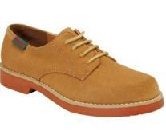
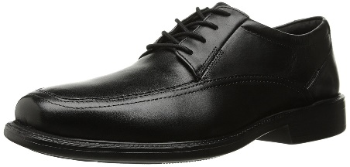

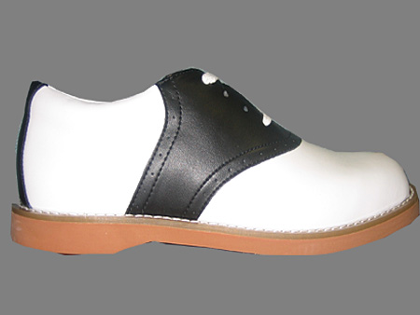
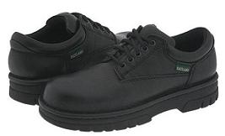

Examples of Unacceptable Shoe Styles
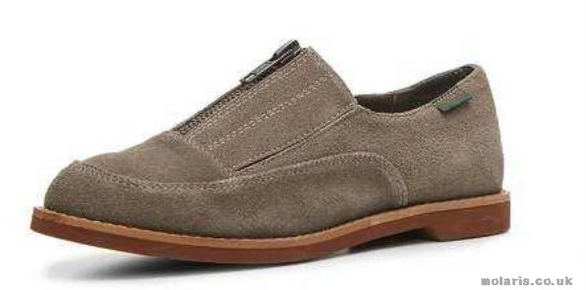
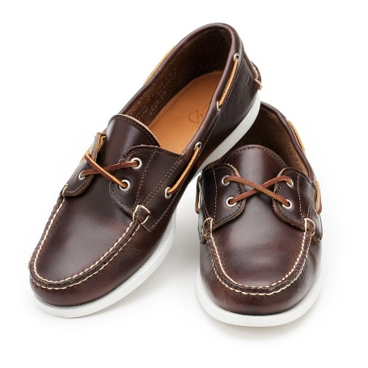

With the Summer Uniform – 8/22/18 through 10/12/2018 and 4/23/19 through 6/2019

Low-top, predominantly dark blue, dark grey, black sneakers or regular school shoes may be worn. Sneakers and shoes must tie, must have heels of one inch or less, and must have rubber soles. Velcro shoes delay development of shoe-tying skills, and are not permitted.

Boys' Uniforms, Kindergarten through Grade 6

Winter (may be worn all year) - Winter Uniforms must be worn by October 15, 2018 through April 17, 2019.

K through 3:
Long navy slacks with white polo shirt, long sleeve or short sleeve. A black, brown, or navy belt must be worn with slacks if they are tailored with belt loops. Pull-on slacks are acceptable for K and 1 only. Black or Navy crew socks are to be worn. Sweaters (optional) are to be long sleeved v-neck, pullover, and solid blue.

4 through 6:
Long navy slacks with white oxford button-down shirt, long sleeve or short sleeve, and the Flynn and O'Hara blue and green striped tie. This tie coordinates with the plaid fabric of the jumpers and kilts. A black, brown, or navy belt must be worn with slacks. Black or Navy crew socks are to be worn. Sweaters (optional) are to be long sleeved v-neck, pullover, and solid blue. Sixth Grade boys may wear a navy blue long sleeved pullover York Catholic sweater.

Summer (optional)
May be worn from 8/22/18 through 10/12/2018 and 4/23/19 through 6/2019

K through 6:
May wear blue walking shorts with white polo shirt. Cargo shorts are not acceptable. A black, brown, or navy belt must be worn with the walking shorts if they are tailored with belt loops. Pull-on shorts are acceptable for K and 1 only. Sixth Grade boys may wear a York Catholic polo shirt. Crew socks which are white, black or navy, are to be worn. Long slacks may be worn with the polo shirt, but shoes, not sneakers, must be worn with long slacks.

Girls' Uniforms, Kindergarten through Grade 6

Winter (may be worn all year) Winter Uniforms must be worn by October 15, 2018 through April 17, 2019.

K through 3:
Green plaid jumper, with white peter-pan collar blouse. Long or short sleeves are permitted. Note: Polo shirts are NOT to be worn with a jumper. Navy blue tights or knee socks must be worn. Leggings must be removed after arrival. The Jumper must be hemmed at 3 inches or less above the knee. Students usually wear shorts under the kilt for modesty. Sweaters (optional) are to be long-sleeved, v-neck pullover, solid blue.

4 through 6:
Green plaid kilt with white oxford button-down shirt. Long or short sleeves are permitted. Navy blue tights or knee socks must be worn. Kilts must be hemmed at 3 inches or less above the knee. Students usually wear shorts under the kilt or skirt for modesty. Flynn and O'Hara offer a skirt in the same fabric which is tailored with a side zipper. This may be purchased instead of the wrap kilt if the fit is better for your daughter. Leggings must be removed after arrival. Sweaters (optional) are to be long-sleeved v-neck, pullover, solid blue. Sixth Grade girls may wear a navy blue, long-sleeved pullover York Catholic Sweater.

Summer (optional)
May be worn from 8/22/18 through 10/12/2018 and 4/23/19 through 6/2019

K through 3:
May wear blue walking shorts with white polo shirt. Cargo shorts are not acceptable. A black, brown, or navy belt must be worn with walking shorts if they are tailored with belt loops. Pull-on shorts are acceptable for K and 1 only. Shorts must be hemmed at 3 inches or less above the knee. White, blue or black crew socks are to be worn.

4 through 6:
A white polo shirt with plaid kilt or skirt from the Winter Uniform must be worn. The hem for the skirt or the kilt must be 3 inches or less above the knee. Sixth Grade girls may wear a York Catholic polo. Students usually wear shorts under the kilt or skirt for modesty. Crew socks which are white, blue, black, or navy-blue knee socks may be worn.

Gym Uniform – Boys and Girls K-6
Winter Uniforms must be worn October 15, 2018 through April 17, 2019.
Long-sleeved navy blue sweatshirt and sweatpants must be worn to and from school over the gym shorts and T-shirt.
Students in K and 1 may wear navy blue sweat pants without wearing gym shorts underneath in winter months. These children should still wear their gym T-shirts under their navy-blue sweatshirts on Gym days. The full sweatsuit is to be worn outside the classroom. Teachers may allow student to remove sweatshirts at their discretion while in the classroom.

Summer
May be worn from 8/22/18 through 10/12/2018 and 4/23/19 through 6/2019
All students, Grades K-6 must wear navy blue gym shorts not less than 3 inches above the knee, and a light gray T-shirt. Race for Education T-shirts are acceptable. Note: No other T-shirt, such as a t-ball or basketball shirt, may be worn on Gym days. Sneakers must be worn on Gym Day by all students, K-6.

A Uniform Exchange is held each year in May. During this event, families may sell outgrown uniform items which are in good condition. This allows all families to purchase needed uniform items at very reasonable prices. A limited number of Uniform Exchange items are kept in the school throughout the year, to assist families as needed. Shoes are not included in the Uniform Exchange.

Non-Uniform Days

Grades K-6, Boys and Girls
On days designated as Non-Uniform days, students' apparel is to be neat, modest and reflect the image of a Catholic school.
- Ripped or torn clothing is not considered neat or modest.
- Sleeveless shirts must be layered with another shirt.
- Hems for shorts or skirts must be 3 inches or less above the knee.
- If leggings are worn, the hem of the shirt must be no more than 6 inches above the knee.
- Sneakers or shoes must allow safe play on the recess yard. Sandals or slip-on shoes are not permitted. Sneakers with wheels are never permitted.
- Wording or graphics on clothing may not be negative, violent, or offensive to others.
- If a student's non-uniform apparel is deemed by the Principal to be inappropriate, an attempt will be made to supply appropriate items from the Uniform Exchange. If appropriate items are not available, parents will be contacted to bring other clothing to school.

