Hello Families,
The 20th Annual Race for Education and Grandparents Day is one week away! We look forward to a day of fun, funds, and fellowship. This day is celebratory for the students who assist in raising $50,000 for their school and get to share their school day with the Grandparents/pals. Please continue to ask friends, family and neighbors to sponsor your child in this Race for Education. It is NOT too late. We will be collecting donations through Race day. Rain Date is Monday, May 6th. Grandparents' Day events take place on Friday regardless of the weather and the Race date.

As incentive for helping to raise money for our school, your child(ren) received an ice cream party this afternoon. Thank you to the generosity of Dairy Queen.

A Pep Rally will be held on Thursday, May 2nd at 2:00 pm in the gym. In keeping with tradition, 6th grade will “reveal” 2019 Race t-shirt (designed by a current student). The cheerleaders will lead a cheer, everyone will learn the warm-up dance and the new ambassadors for the school will be announced. All are welcome to attend.

At home, the morning of Race Day:
- Apply sunscreen, apply any fun bling (hair color, spray glitter, etc.) – WE ARE ATTENDING MASS IN THE MORNING THIS YEAR, so students should PACK accessories in a bag labeled with your child’s name.
- Student should wear gym shorts, sneakers and their 2019 Race shirt that day. If it is cool, they may bring a sweatshirt too. Please be sure the sweatshirt is labeled with their name.
- Bring a water bottle with the student’s name on it to use during the race. We will have water to refill the bottles.
- If your child is in the choir, altar service, usher or in the Mass, they should wear their school uniform including socks & shoes for Mass and pack their gym shorts, sneakers and 2019 race shirt.
- If your child uses an inhaler at school, please check with Mrs. Querci.

Information for Volunteers:
- All volunteers, including teens, please visit the Volunteer Tent to check in and pick up your name badge for Race day. All must have signed-up and completed the clearance process to assist.
- Restrooms for visitors will be available at the church and the upper hall bathrooms only.

Information for Grandparents:
8:00 Students arrive at school
8:00-8:30 Grandparent arrive to church. Student will walk over from school with their class
8:30 - 9:30 Mass
9:30 Students return to class
9:30 - 10:00 Grandparents have a social in Narthex of the church
10:15 Tours by ambassadors
10:15 - 10:45 Lower Hall Classroom visits, Grandparents HUB and/or Cafeteria
10:45- 11:15 Upper Hall Classroom visits, Grandparents HUB and/or Cafeteria

- Families who have more than one child in the school, may not get to each child's classroom for a visit. There are many opportunities to spend time with them throughout the day: at the Race, at lunch, in the classrooms, as well as sitting with them at Mass. Restrooms for visitors will be available at the church and the upper hall bathrooms only.

The Grand Hub - A retreat for our Grandparents & GrandPals in the Library. We will offer drinks, a slideshow of our students & school over the years, opportunity for grands to write notes to their grandchildren, flip through yearbooks, and mingle or relax. We encourage grands to visit.

Race Times & Grandparents Tent - Families, friends and grandparents are welcome to watch the children race, or race (run or walk) with them. We will have a large tent which will have limited seating, drinks and snacks for the grandparents to enjoy. Grandparents are welcome to bring folding chairs. Race times are: NOTE CHANGE IN TIMES
Preschool, Kindergarten & 1st Grade 12:10 – 12:40 P.M.
2nd & 3rd Grade 12:50 - 1:30 P.M.
4th, 5th & 6th Grades 1:50 – 2:20 P.M.

Grandparents Lunch
Tables will be arranged alphabetically by STUDENTS' last names. Grandparents will be directed/escorted to the appropriate table as they check in. Please note that we have adjusted the start of lunch from their usual times.

Lunch Times
CLASS | ENTER CAFETERIA | EXIT CAFETERIA
KINDERGARTEN | 10:50 | 11:20
1ST GRADE | 11:00 | 11:30
2ND GRADE | 11:10 | 11:40
3RD GRADE | 11:20 | 11:50
4TH GRADE | 11:30 | 11:55
5TH GRADE | 11:40 | 12:05
6TH GRADE | 11:50 | 12:15

End of Day
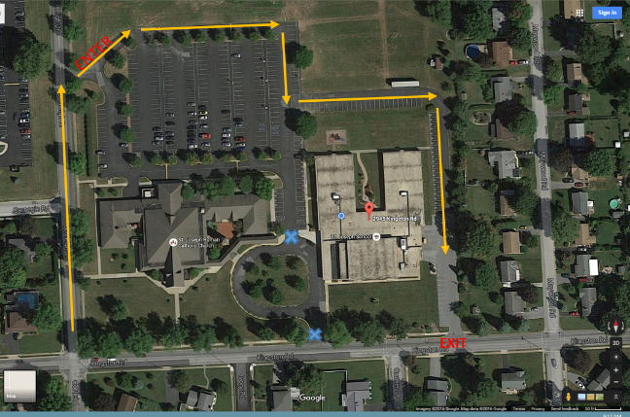
If your child(ren) is going home with their grandparents, please send a note in to the office. As a safety policy - No child may leave directly from Race with their grandparent.

If your grandparents/grandpals will be picking up in the car rider line, please explain to them how our process works. Dismissal procedures are as follows: enter via Cortleigh Road and follow the traffic line to the north and east of the school building. Car riders are dismissed from the East door of the school. Drivers are to form two lines and remain in their cars until school staff escorts the children to each car. We will have volunteers in the parking lot instructing them where to go, but it will be helpful to everyone if they are familiar with the process in advance.

THANK YOU to all who helped plan and prepare for one of the best days of the year. This day is FUN and raises much needed FUNDS for our school. For those who are new to this day, you will see how we could not possibly manage the day without our amazing volunteers!
2019 Race Committee (Charlene Brady, Alison Devitt, Linda Francis, Kristi Hissong, Nicole King, Alli Stover)
Kristy Byrnes Baker, Development Director, 717-755-1797 x328 or Development@sjy.org

